A message for ESD and WorkSource partners
The Employment Security Department is taking steps to increase the level of security relating to email messages that may include confidential or restricted data like social security numbers.
As part of these steps, ESD is implementing a new Secure Email Portal. Outbound email messages from ESD staff that contain confidential or restricted data will be routed to this portal. Once an encrypted message has been sent, you will receive notification informing you that there is a secured email waiting for you. To retrieve this email,
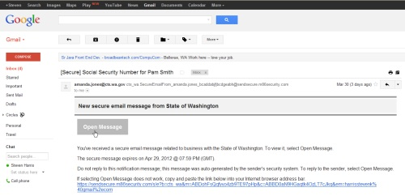
- Click on the “Open Message” button, which will take you to the new registration page.
- Enter a password that meets the requirements posted on that page.
- Click the “Register” button, which will route you to your secure email messages.
Once you have registered, secured e-mail correspondence from ESD will only require the registered user to enter the established password.
Once you have registered successfully and established a password, any future secured e-mail correspondence from ESD will only require you (the registered user) to enter your established password.
Complete instructions for secure email are available online.
For customer support, email the Washington State Consolidated Technology Services (CTS) Service Desk or call 888-241-7597; TTY at 800-833-6388.

