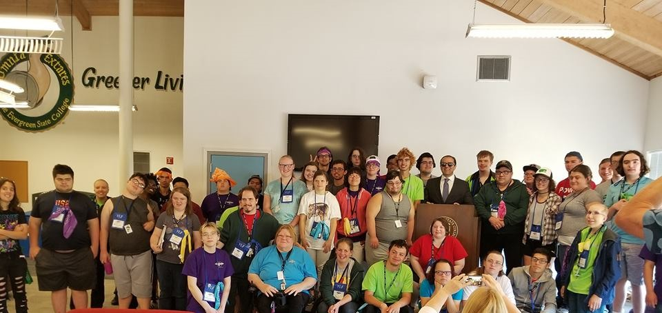

Initial Application Packet

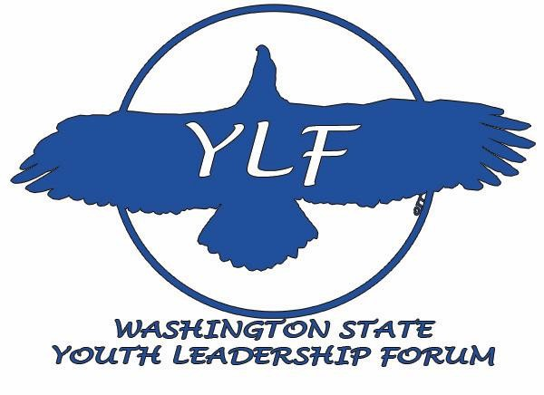

19th Annual Youth Leadership Forum
August 4-9, 2019
Dumas Bay Centre, Federal Way, WA

Initial deadline to apply: May 30, 2019
(Applications after that date will be accepted on a
“as space allows” basis.)
We are looking for future community leaders!!

Eligibility
This is the initial application consisting of the application, student essay questions, signature page, and professional endorsement. The application is a fillable document and may be saved as a file. The student signature page and professional endorsement must be either scanned in and emailed or mailed to the address listed.
The program is funded to allow participation by approximately 30 to 50 high school students/students-in- transition with disabilities from throughout Washington State to attend.
In order to allow for as many eligible students to participate, a youth may only attend YLF as a delegate once during their period of eligibility.
There is no cost to the student/parent/guardian for the student to attend YLF. All expenses, including travel to and from the Forums are full funded.
Students must be 16 years of age prior to the start of YLF and under the age of 22.
All disabilities are accepted and YLF pays for any needed accommodations or assistance.

The Youth Leadership Forum is a project of the Washington State Governor’s Committee on Disability Issues and Employment.

Come join us for the 19th Youth Leadership Forum for High School Students with Disabilities, an exciting, fun, educational, five-night, six-day,
Program for youth in transition under the age of 22!!

Application instructions:
- Students must complete all information on pages 3-5 of this fillable application. (If you need help, please ask your parents or teachers or you can call Elaine Stefanowicz, at (360) 902-9362.)

- Please type or print with black or blue ink. If you require an alternative format, please contact Elaine Stefanowicz.

- Mail/Email/Scan the application to:
Governor’s Committee on Disability Issues and Employment, Youth Leadership Forum, Attn: Elaine Stefanowicz, PO Box 9046, Olympia, Washington 98507-9046 Email: estefanowicz@esd.wa.gov

Youth Leadership Forum Application
Initial Due Date – May 30, 2019
Application
Student’s Name:

Gender:

Date of Birth: Age at Start of YLF (August 4, 2019):
If over 18 years, of age, do you have a Legal Guardian: Yes No

Mailing Address:

Street Address/P.O. Box

City, State & Zip Code

Student’s Email Address:

Student’s Cellphone Number (including area code):

Parent(s)/Guardian(s)’s Name:

Parent(s)/Guardian(s)’s Email Address:

Parent(s)/Guardian(s)’s Phone Number:

Attending High School: Yes No

Enrolled in a Transition Program: Yes No

Name of High School/Transition Program:
Mailing Address of School/Transition Program:

Street Address/P.O. Box

City, State & Zip Code

School/Transition Program Phone Number:

Name of High School/Transition Program Counselor:

Grade Level on July 1, 2019 (must be a junior, senior, recent graduate or enrolled in a transition program):
If graduate, date of graduation:

Are you receiving Services from the Division of Vocational Rehabilitation, Developmental Disabilities Administration, or Department of Services for the Blind? Yes No

Do you have an IEP/504? Yes No

Student Essay Questions

Your answers to the following questions will be used to assess your interest and readiness to participate in the Youth Leadership Forum. Please type your responses in the space provided or on separate sheets of paper(s) and attach it to your application packet. Your total responses for all four of these topics should not exceed two (2) typewritten, double-spaced pages.

- What are two important experiences (good or bad) you have had as a young person with a disability? (Please be specific about your examples as they relate to your disability.)

- In terms of leadership, please tell us about two people who have positively influenced your life and why. (Family members, teachers, counselors, friends, public officials or celebrities are appropriate examples.)

- Why do you feel you are qualified to be a delegate to this Youth Leadership Forum and please tell us why you want to attend this Forum?

- Describe your goals for after high school graduation.

[If you are planning to email your application, please be sure to print pages 6 and 7 and scan them for inclusion with your email or mail them. We must have signatures on the application.]

Student Signature
I have completed the Youth Leadership Forum Application and understand that I will be contacted regarding my selection by June 10, 2019. I understand that this is the initial application packet and a second packet will be provided that will include the opportunity for me to request accommodations and assistance (if needed), special dietary needs, travel arrangements and other information.

Signature of Student: Date:

Signature of Parent/Guardian (if under 18): Date:

Signature of Legal Guardian (if over 18, and appointed): Date:

This document must be signed and returned to: Governor’s Committee on Disability Issues and Employment, Youth Leadership Forum, Attn: Elaine Stefanowicz, PO Box 9046, Olympia, Washington 98507-9046; Email: estefanowicz@esd.wa.gov by May 30, 2019.

Professional Endorsement

I, ___________________, have requested that
Student’s Name Teacher, Counselor, Mentor

provide this endorsement of my application to the Youth Leadership Forum (YLF). I have provided them a copy of the YLF brochure so that they may comment on the benefit of my attendance as well as the strengths I bring to the Forum that will benefit other participants. This endorsement will be used to tailor the Forum to the needs of the participants.

___________________
Student signature Date Guardian signature (if required) Date

Please complete the following endorsement and return it to: Governor’s Committee on Disability Issues and Employment, Youth Leadership Forum, Attn: Elaine Stefanowicz, PO Box 9046, Olympia, Washington 98507-9046; Email: estefanowicz@esd.wa.gov by May 30, 2019.

Name: _____________________

Title:
Organization:
Name, address, and telephone number

Relationship to student:
Years known:
[On the reverse side of this page or another piece of paper, please provide a brief summary of the benefits this student would receive from attending YLF and what strengths the student will bring to the Forum that will benefit other participants. Your responses will not eliminate the student from the program but will be used to better tailor the program to the needs of the participants.]

