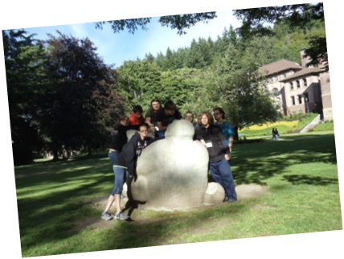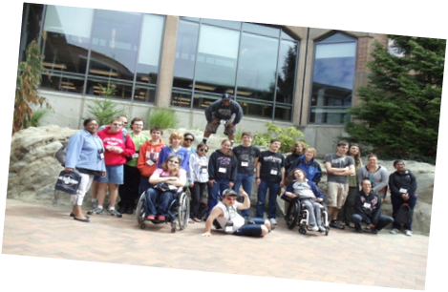

We are looking for future community leaders!!

Come join us for the 18th Youth Leadership Forum for High School Students with Disabilities, an exciting, fun, educational, five-night, six-day,
Leadership Program!!

The Youth Leadership Forum is a project of the Washington State Governor’s Committee on Disability Issues and Employment

*************************
Deadline to apply: June 1, 2018

WHO: Approximately 35-50 high school students with disabilities will be selected to attend the Forum through a competitive process.

WHEN: July 22 – 27, 2018

WHERE: The Evergreen State College,
Olympia, Washington

COST: Students/Parents will not be charged expenses to attend this Forum

Please fill out this application, save and then email/scan it to Elaine Stefanowicz; estefanowicz@esd.wa.gov.

- Students must complete all information on pages 1– 4 of this application. (If you need help, please ask your parents or teachers or you can call Elaine Stefanowicz, at (360) 902-9362.

- Please type or print with black or blue ink or send Braille, audiotape or computer disk.

- Mail/Email/Scan the application to the address on the last page.

- If you would like a fillable Word document, contact Elaine.

Youth Leadership Forum Application
Due Date – June 1, 2018

1. Student’s Name:
2. Gender: Date of Birth:
3. Mailing Address:

City, State & Zip Code

Email Address
4. ( ) ( )
Home Phone Number Cell Number
Parent’s Email Address:
5. Name of High School:
High School Phone Number: ( )
6. Are you receiving Transition Services from the Division of Vocational Rehabilitation (DVR/DSB) Department of Services for the Blind?
Yes No

7. Grade Level on July 1, 2018 (must be a junior, senior or recent graduate):

8. High School Graduation Date:
9. School and Community Involvement:
Please list any extra-curricular involvement with your school and community. (This may include offices you have held, club memberships, after school activities or work experiences.)

YLF Application, Page 2
Student’s Name:

School-related extracurricular activities:

*Activity:
Grade Level: Dates:

*Activity:
Grade Level: Dates:

*Activity:
Grade Level: Dates:

Community-based extracurricular activities:

*Activity:
Grade Level: Dates:

*Activity:
Grade Level: Dates:

*Activity:
Grade Level: Dates:

10. References:

- High School Representative (teacher, principal, counselor, coach, etc.):
Name:
Title:
Organization:
Phone: Email:
YLF Application, Page 3
Student’s Name:
- Community Representative
(employer, coach, counselor, friend of the family, etc.)

Name:
Title:
Organization:
Phone: Email:

11. Survey of Personal Interests

Responses must be doubled-spaced and typed or printed in black or blue ink.

Your answers to the following questions will be used to assess your interest and readiness to participate in the Youth Leadership Forum. Please write/type your responses on separate sheets of paper(s) and attach it to your application packet. Your total responses for all four of these topics should not exceed four (4) typewritten, double-spaced pages.
YLF Application, Page 4
Student’s Name:

(a) Experiences as a person with a disability –What are two important experiences (good or bad) you have had as a young person with a disability? (Please be specific about your examples as they relate to your disability.)

(b) In terms of leadership, please tell us about two people who have positively influenced your life and why. (Family members, teachers, counselors, friends, public officials or celebrities are appropriate examples.)

(c) Why do you feel you are qualified to be a delegate to this Youth Leadership Forum and please tell us why you want to attend this Forum?

(d) Describe your future plans after high school graduation.

YLF Application, Page 5
Student’s Name:

12. **Your answers to the following will not deny you from participation in the Forum. Please answer the following by inserting the number that corresponds to the statement.

Other Information:

- Student is able to maintain their personal hygiene (shower/bath, brush teeth and toilet).

1 – 4 Needs assistance with personal hygiene.
5 – 7 Needs reminders to complete personal hygiene.
8 - 10 Independently maintains personal hygiene.

b. Student is independently ready for routine scheduled events (activities, meals, etc.).

1 – 4 Needs assistance with routine scheduled events.
5 – 7 Needs reminders to complete routine scheduled events.
8 - 10 Independent and ready for routine scheduled events.

c. Student responds appropriately personal safety and emergencies (alarms, weather, etc.).

1 – 4 Needs assistance to maintain personal safety.
5 – 7 Needs reminders to maintain personal safety.
8 - 10 Responds appropriately to personal safety & emergencies.

YLF Application, Page 6
Student’s Name:

I have completed the Youth Leadership Forum Application and understand that I will be contacted regarding my attendance by
June 10, 2018.

13. __________________________________________
Signature of Student: Date:

14. _________________________________________
Signature of Parent/Guardian: Date:

Phone # of Parent:

(Please provide the phone number of a parent if you are under the age of 18.)

(If you are over 18 and on your own, you don’t have to have the signature of a parent/guardian).

_____________________________________________
Printed Name of Parent/Guardian

T-Shirt Size (need to place the order early)

X-Small
Small
Medium
Large
X-Large
XX-Large
XXX-Large

YLF Application, Page 7
Student’s Name:

(Keep for Your Records, DO NOT RETURN)

Please use the checklist below to make certain your application packet is complete. Incomplete applications will not be considered.

Check List Completed [ ]
1. Application form (6 pages) [ ]
2. Signed application (Student & Parent/Guardian) [ ]
3. Survey of Personal Interest (response to 4 topics) [ ]
4. Photocopy application for your records [ ]
5. Photo of Student [ ]

14. Please mail, email or FAX the application to the address below. If you would like to receive this application in an online format or if you have any questions, please contact:

Governor’s Committee on Disability Issues and Employment
Elaine Stefanowicz
PO Box 9046
Olympia, Washington 98507-9046

Email: estefanowicz@esd.wa.gov

(360) 902-9362
(360) 586-4600 FAX

Applications must be emailed/postmarked by
June 1, 2018 for consideration!!

Thank you for completing this application!

